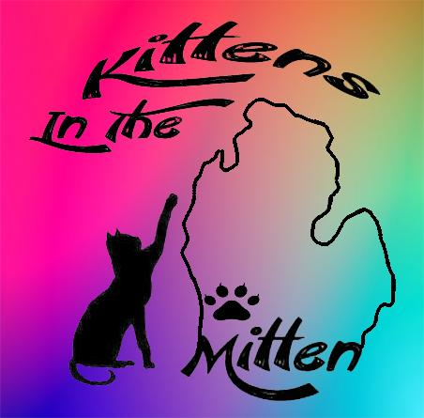

Name of cat/kitten you are applying for?
_______________________________

Paid by:_______ Amount paid:______

Cat/Kitten Adoption Application
1. No animal will be released for adoption unless deemed healthy by Kittens In The Mitten or the Adoption Committee.
2. Animals will not be adopted out that are to be given as gifts, except those from a parent to a domicile minor child.
3. No animals will be adopted for “outside only” homes.
4. Animals will not be adopted to minors. Adopters must be 18 years of age or older.
5. All animals in the home must be spayed or neutered and have current vaccines.
6. All residents of the home must agree to and be informed of the adoption.
7. An adoption application must be completed and approved by the Executive Director or a member of the Adoption Committee. The adoption fee must be paid in full, before the adoption can take place.
8. If you decide to return the animal to Kittens In The Mitten, within two weeks of the adoption, HALF of the adoption fee will be refunded. The full adoption amount is NON-REFUNDABLE after two weeks. If you adopt a bonded pair or siblings, BOTH must be returned.
9. Landlords, housing authorities or housing associations must approve pets on premises prior to approval of adoption by Kittens In The Mitten, before the animal is allowed to leave our care.
10. Adoptee is required to notify Kittens In The Mitten in the event that the home is no longer suitable for the animal. Arrangements must be made 24 hours in advance to return the adopted animal to Kittens In The Mitten. The adoptee is not permitted to rehome the adopted animal via another Humane Society or use of social media i.e. Facebook or Craigslist.
11. We do not allow single kittens to be adopted into no-cat households! Cat's especially kittens, are colony animals and do best with other members of their own species. If you have no previous cats in your household we ask that you adopt two kittens or an adult cat that enjoys his/her space.
12. If pre-adopting a cat or kitten, we ask for $50(adult cats) $75(1 kitten) $100(2 kittens) of their adoption fee. The remaining amount will be due at time of adoption. This money is non-refundable if you decide against adopting.
13. Filling out this form does not guarantee an adoption will be approved. We reserve the right to deny any application without reason.

CAT AND KITTEN HEALTH STATEMENT
Thank you for considering adopting a cat or kitten from Kittens In The Mitten. When cats and kittens arrive at our fosters, he/she is vaccinated, dewormed, spayed/neutered, microchipped, and feline leukemia tested. Kittens In The Mitten will test the mother of the kittens, if she is positive all kittens will be tested. If no mother present one kitten from the litter will be tested. If positive, all kittens from the litter will be tested. Feline Immunodeficiency Virus (FIV) and Feline Leukemia that can be passed from the mother of the kittens in the litter. A negative test is a good indicator but does not ensure that a kitten is negative. Any additional or individual tests above and beyond would be at the discretion and/or expense of the adopter. We treat the animals for whatever health problems we see while they are with us. Unfortunately, the cats and kittens may leave Kittens In The Mitten, looking healthy but may come down with an illness after they get home. For this reason, do not expose the cat or kitten to other cats for at least two weeks. The most common of these illnesses is the “kitty cold” or upper respiratory infection. The common signs of the kitty cold are similar to humans and include sneezing, runny nose, watery eyes and chest congestion. This can become serious if not treated promptly. You will need to take your cat or kitten to a veterinarian. The cost for diagnosis and treatment may be more than $100. Please be aware of this possibility before agreeing to the adoption.
There are other illnesses that may affect cats and kittens. Some of the illnesses that we have encountered include Ringworm, FIP (Feline Infectious Peritonitis), FIV (Feline Immunodeficiency Virus) and diarrhea due to change in diet. Your pet may be on a special diet. Please discuss with staff if this is applicable. If you decide to change the food brand, it should be mixed gradually over a period of two (2) weeks with the food the animal is currently receiving. Please feel free to talk to us if you have any concerns or questions about any symptoms your pet may be experiencing or exhibiting. You, “the owner,” will be financially responsible for any veterinarian and/or medical bills that this cat or kitten may incur once you adopt and the animal leaves our premises.
Please write legibly.

First Name___________________________
Last Name ___________________________
Address _____________________________________
City _________________________________
State _________ Zip Code ____________
Email________________________________
Home Phone _________________________
Cell Phone ___________________________
Work Phone __________________________
Best number to contact you? _____________________________________

Name of Cat/Kitten you are applying to adopt? ______________________
What is your experience with cats/kittens? _________________________________
Do you own or rent your home? ___________________________
If you rent, have you received approval from your landlord to have a pet? ______________
Name and phone number of landlord? _____________________________________
In what type of home do you live? ___________________________________
How many adults reside in the home? _____________________________________
Do you have children? _______________ What are the ages?__________________
Is anyone residing in the home allergic to cats? __________________________
Who in the household will care for the cat/kitten? ___________________________
Do you currently have any pets? __________________________________
If yes, please tell us the name of the pet(s), species, breed(s) and age(S). __________________________________
__________________________________
__________________________________
Please provide vet’s name and phone number that you will be using. __________________________________
Under what circumstances might you decide to give up a pet? __________________________________
If you are chosen to adopt, when would you be ready to take possession of the rescue cat or kitten?
__________________________________

We do not allow declawing of our cats or kittens. Below is our declaw contract. This is to make sure no adoptee can legally declaw one of our rescues.
Kittens In The Mitten is placing, ___________________, in your home with the agreement that you, ___________________, will not declaw at any time. Failure to go against this contract will void the adoption contract with Kittens In The Mitten and adopter, and ____________ must be returned Kittens In The Mitten.

Adopter’s Signature: ____________________
Date: _____________
Kittens In The Mitten staff Signature: ___________________________________

Kittens In The Mitten Cat Rescue
3588 Lincoln Rd. Hamilton, MI 49419
616-405-6664
We are a foster based rescue. The above address is for mailing purposes ONLY!!

